**Assignment 3**

**Memory Management**

1. Setup additional swap space in the system to solve low memory issue. The swap which you added should be available post reboot.

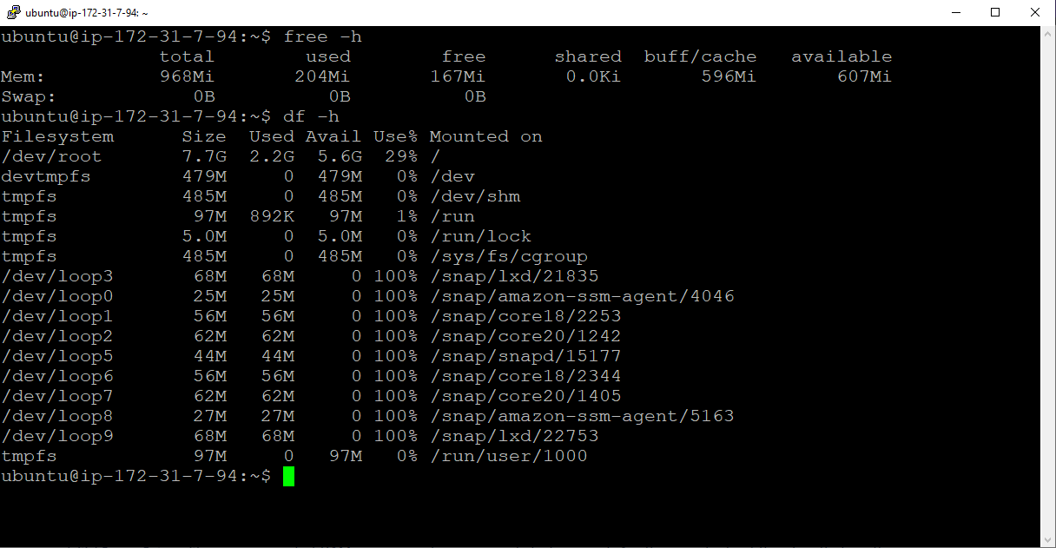

Commands :

free -h :- checking swap memory.

df -h :- checking current disk usage

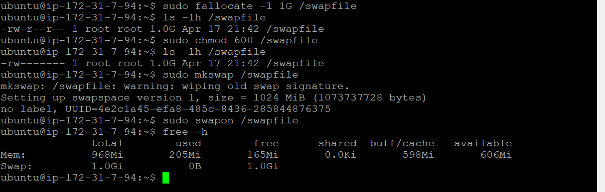

Commands :

sudo fallocate -l 1G /swapfile :- Creating swapfile of 1GB size

sudo chmod 600 /swapfile :- give read write permission for root user only

ls -h /swapfile :- verify the permissions

sudo mkswap /swapfile :- creating a swap space

sudo swapon /swapfile :- Enable the swap file

free –h :- checking swap memory.

1. Find out the number of process is in run queue and blocking queue.

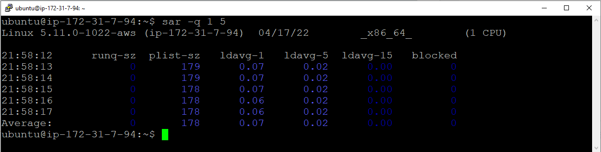

Commands :

sar -q 1 5 :- checking report of running queue and blocking queue